Predicting the Popularity of Songs on Spotify
Introduction
The popularity of songs on streaming platforms such as Spotify has become an important area of study in music analytics. Popularity of songs can reflect consumer preferences, trends, and industry promotion. The main research question for this study is: How can we best predict the popularity of a song on Spotify. This is particularly interesting because Spotify’s algorithms and curated playlists are influenced by song popularity. Understanding popularity patterns can provide insights into how music reaches audiences. From the perspective of users, understanding popularity trends can help explain why some songs are heavily promoted or end up more frequently in curated playlists. Users show interest in their personal music metrics through Spotify Wrapped and third party data tracking services, so they would be interested in this additional data. For artists, this information can help them grow their audience by understanding how to best reach the largest audience possible.
To address this question, the Kaggle dataset Spotify Music Dataset was used. By applying regression-based approaches to this dataset, this project aims to identify which features are most predictive of song popularity. Additionally, strengths and weaknesses of different modeling strategies will be evaluated in the context of highly variable and noisy data.

Data Exploration and Preparation
For this project, the Kaggle dataset Spotify Music Dataset was used. This dataset has 4831 observations of 29 variables. The numerical variables included speechiness, danceability, energy, instrumentalness, valence, tempo, loudness, acousticness, and liveness. The integer variables included time_signature, track_popularity, duration_ms, mode, and key. The character variables included playlist_name, track_artist, playlist_genre, playlist_subgenre, track_href, track_name, uri, type, analysis_url, id, track_album_id, playlist_id, track_id, and track_album_name. The columns track_href, track_name, uri, track_album_release_date, analysis_url, id, track_album_id, playlist_id, and track_id are all identifier columns. The identifier columns will be excluded for analysis since they are unique for each song. Variables that could be potentially useful for modeling popularity include speechiness, danceability, energy, playlist_genre, instrumentalness, valence, key, tempo, loudness, and acousticness.

Data Cleaning
For cleaning and analysis, a separate dataset called merged_spotify_relevant was created. This new dataset included just variables from the original data that could be useful for predicting popularity of songs. These variables included time_signature, track_popularity, speechiness, danceability, playlist_name, track_artist, duration_ms, energy, playlist_genre, playlist_subgenre, mode, instrumentalness, valence, key, tempo, loudness, acousticness, and liveness.
The percentage of missing values for each column was calculated. The many columns were not missing any data, but the variables time_signature, danceability, duration_ms, mode, instrumentalness, tempo, liveness, energy, valence, loudness, track_album_name, speechiness, key, and acousticness were all missing about 2% of values. Rows with NA values were removed from merged_spotify_relevant. Only one row had NA values, resulting in a total of 4830 observations remaining in merged_spotify_relevant. Additional, variable types were changed as necessary for consistency and to match their functions.

Summary Statistics
Summary statistics for all numeric variables in merged_spotify_relevant are shown in Table 1. Several variables, such as instrumentalness, acousticness, speechiness, and liveness, showed a strong right skew with many observations near zero. Track popularity showed a moderate spread with no extreme outliers. Additionally, the frequency of categorical variables was explored. The variable playlist_genre had 35 different levels. The variable playlist_subgenre had 84 different levels. The variable playlist_name had 116 levels. The variable track_artist had 3390 different levels. The variable album_name had 3816 different levels.

Correlation Matrix
A correlation matrix was generated for numeric variables (Table 2). Overall, correlations between track popularity and other variables were relatively small. The variables that had the strongest correlations with track popularity were instrumentalness (r = -0.26), loudness (r = 0.22), and acousticness (r = -0.23). Several pairs of explanatory variables showed stronger correlations. Danceability and valence (r = 0.51) and danceability and loudness (r = 0.56) had moderate positive correlations. Energy was strongly correlated with several variables, such as loudness (r = 0.80), acousticness (r = -0.75), and instrumentalness (r = -0.56). Loudness showed inverse correlations with instrumentalness (r = -0.64) and acousticness (r = -0.65). These relatively high magnitude correlations between explanatory variables suggest that many variables, and audio metrics in general, have overlapping information. This could reflect musical characteristics such as production style, genre, and when the song was released.

Initial Scatterplots
Initial scatterplots were generated to visualize the relationship between track popularity and potential explanatory variables (Figures 1-8). Plotting these relationships allowed for an early assessment of distributional patterns, potential nonlinear relationships, and whether variables appeared to have a meaningful association with popularity. The majority of the scatterplots showed little to no visible trend (danceability, energy, valence, tempo, and acousticness). Speechiness showed a large concentration of observations near the low end of the speechiness scale, followed by a gradual feathering out as speechiness increased. This pattern suggests that most songs in the data contain relatively little spoken content and have no clear linear trend with popularity. The instrumentalness scatterplot showed two prominent vertical clusters. One cluster was near zero (non-instrumental songs) and the other was near one (fully instrumental songs). There was a scatter of points between these two extremes. There is not a clear directional trend here, but this numerical variable seems to behave almost categorically. The scatterplot for loudness showed a horn-shaped pattern, with a wide vertical spread for songs at the loudest end of the X-axis. As loudness decreased toward zero, the spread in popularity narrowed. This trend may suggest that louder songs have a greater variability in popularity than quieter songs.

Methods
First, a full linear regression model was utilized, meaning that all variables and all possible interaction terms were included. The purpose of attempting a full linear regression model was to gain an initial sense of the structure of the dataset. By evaluating significance, coefficients, and resulting diagnostics from a full linear regression model, predictors that show strong effects and significant interaction terms can be identified. Initial exploratory models help provide a baseline understanding of potential relationships within complex data. The goal of this model was entirely diagnostic, attempting to examine broad trends and identify influential features for downstream analysis.
Next, a reduced linear regression model was fit. This reduced model included just the most important variables and excluded interaction terms. This model addressed issues in the full linear regression model by simplifying the structure and focusing on just main effects that could be meaningful based on initial exploration. This allowed for a more interpretable model and provided a clearer picture of the relationships explanatory variables had with popularity. This model helped move in the right direction by removing noisy variables and unnecessary predictors.
To refine the reduced linear regression model, variable selection was performed via stepwise regression. This procedure used stepwise selection minimizing AIC. At each step, variables are added/removed to minimize AIC. This allows the model to balance model fit and complexity. This process helped identify a streamlined linear model that only included predictors that meaningfully contributed to explaining changes in popularity.
Additionally, a regression model incorporating B-spline transformations of each predictor variable was tested. Splines can be useful for nonlinear relationships between explanatory variables and the response variable since they allow the model to locally adapt without imposing the same structure on the whole model. When using splines, it is important to be mindful of overfitting. Using splines allowed nonlinear patterns in the predictors to be captured. This model provides insight into whether accounting for nonlinear effects improved performance of predicting popularity relative to linear approaches.
Finally, an elastic net regression model was utilized to fit the data and predict popularity of songs. Since the main research question involves prediction popularity of songs based on other variables, it makes the most sense to use a model meant for prediction. Elastic net combines features of LASSO and Ridge regression. The LASSO component performs feature selection to reduce the number of explanatory variables, while the Ridge component stabilizes coefficients in the presence of multicolinearity and prevents overfitting. Through cross validation, the mixing parameter (α) and regularization strength (λ) were optimized. This allows the elastic net regression model to provide a balanced and data-driven approach that can have increased predictive accuracy.
For each model, assumptions of normality and heteroscedasiticty were evaluated using both graphical methods and formal statistical tests. Normality was assessed using the Kolmogorov-Smirnov test and heteroscedasticity was evaluated using the Breusch-Pagan test. These diagnostic tests ensured that model assumptions were examined for interpreting results and comparing performance across models.

Results
Full Linear Regression Model
The full linear regression model included all predictors and interactions from the dataset merged_spotify_relevant. This model returned the error “Error vector memory limit of 16 Gb reached”. This error is to be expected due to the high number of levels of many categorical variables. Playlist name has 116 levels, playlist_genre has 35 levels, and playlist_subgenre has 84 levels. Therefore the number of resulting dummy variables and interaction terms exceeded realistic memory limits, making it impossible to account for all variables and interactions. This prompted the use of reduced models.

Reduced Linear Regression Model
A reduced linear regression model using only main effects was successfully fitted. Significant predictors included time_signature, speechiness, duration_ms, instrumentalness, valence, and acousticness. (p < 0.05). However, adjusted R² was low (R² = 0.08878). This indicates that linear effects alone captured limited variance in popularity. Diagnostics revealed that this model violated both assumptions of normality (Kolmogorov-Smirnov test: p < 2.2e-16) and homoscedasticity (Breusch-Pagan test: p < 2.2e-16). These findings support exploration of flexible modeling approaches.
Stepwise selection minimizing AIC removed predictors with limited explanatory value. The final model after stepwise selection retained the variables time_signature, speechiness, danceability, duration_ms, energy, instrumentalness, valence, key, loudness, and acousticness. The variables mode, tempo, and liveness were eliminated. Additionally, the adjusted R² stayed very stable compared to the model before variable selection (R² = 0.08878). This model still violated assumptions of normality (Kolmogorov-Smirnov test: p < 2.2e-16) and homoscedaticity (Breusch-Pagan test: p < 2.2e-16). This suggests that the majority of variables of interest do have some correlation to popularity, but the effect size may be relatively small. Overall, due to small effect sizes, low signals, and noisy data. A linear regression model might not be an optimal fit for this data.

Spline Model
Additionally, a regression model incorporating B-spline transformations of each predictor variable was tested. Numeric variables were transformed via B-spline with parameters specified to use 6 basis functions, with 3 interior knots, and a cubic spline (degree=3). For this model, the adjusted R² increased slightly to (R² = 0.1432). This model still violated assumptions of normality (Kolmogorov-Smirnov test: p < 2.2e-16) and homoscedasticity (Breusch-Pagan test: p < 2.2e-16). Although a spline model can help capture non-linearity, for a research question focused on prediction with noisy data, it makes more sense to pivot toward models more geared toward prediction.

Elastic Net Model
Elastic net regression was used to optimize predictive performance while addressing multicollinearity and reducing the model complexity. Cross-validation was used to identify optimal values of alpha (α = 0.5) and lambda (λ = 0.2086177). The mean squared error of this model (MSE = 111.6) suggests moderate error. The Root Mean Squared Error (RMSE = 10.57) means that the predictions are typically off by about 10.6 units (same scale as outcome variable). The Mean Absolute Error (MAE = 7.50) shows that predictions are off by an average of 7.5 units. Since RMSE (10.57) is higher than MAE (7.50), these may be some larger errors that inflate RMSE. Finally, the R² improved in this model (R² = 0.724). The elastic net model explains 72.4% of the variance in song popularity. This is a relatively strong model fit. Figure 9 plots the elastic net popularity predictions compared to the observed track popularity. Although there is noticeable spread in the data, the similarity between prediction and ground truth is visible.

Discussion
After exploring multiple modeling approaches, it is clear that the elastic net regression model provided the strongest predictive performance for estimating the popularity of songs on Spotify. The elastic net model achieved higher explanatory power (R² = 0.724) and relatively low predictive error (RMSE = 10.57). One of the strengths of elastic net models is the ability to balance feature selection with regularization, which allows the model to stay accurate even when predictors are correlated. This is important for this data since multiple explanatory variables were found to have some correlation with each other.
However, there are still limitations with this study. First, it is unclear why this specific selection of songs was chosen when there are many more than ~5000 songs on Spotify. It is unclear whether these predictions would generalize to data outside of this dataset. Additionally, many variables that could be important were excluded due to their excessive number of levels. The inability to incorporate genre, sub-genre, playlist name, artist, or album could have weakened the model’s explanatory capabilities. Further, although the elastic net model had strong predictive power, the error suggests that there are external factors that play an important role in popularity and aren’t captured in this dataset. Such factors could include marketing, artist fame, social media, label promotion, etc. None of these factors are captured in this data.

Conclusion
This study explored a variety of approaches to predicting popularity of songs on Spotify using data from a publicly available Kaggle dataset. Initial linear and spline-based regression models had limited predictive power due to noisy data and complex relationships. The elastic net regression model provided the best accuracy, explaining 72.4% of variance in popularity. This shows that audio characteristics contain information about a song’s popularity, even if individual effect sizes are small.
These findings are important because they help understand how musical attributes contribute to the visibility of songs on streaming platforms such as Spotify. This has implications for artists and producers that want to know how their music might perform on streaming services. It is also useful for analysts that want to study larger-scale patterns in listening behavior.
In the future, it would be interesting to model each genre separately. Genre-specific prediction models could better isolate relationships between explanatory variables and popularity. Additionally, other models could be explored, such as random forests or neural networks. Such models could incorporate the genre information directly without facing memory limitations. Overall, this project demonstrates the strengths and limitations of predicting music popularity based on limited variables, building a foundation for more advanced modeling in music analytics.
Figures

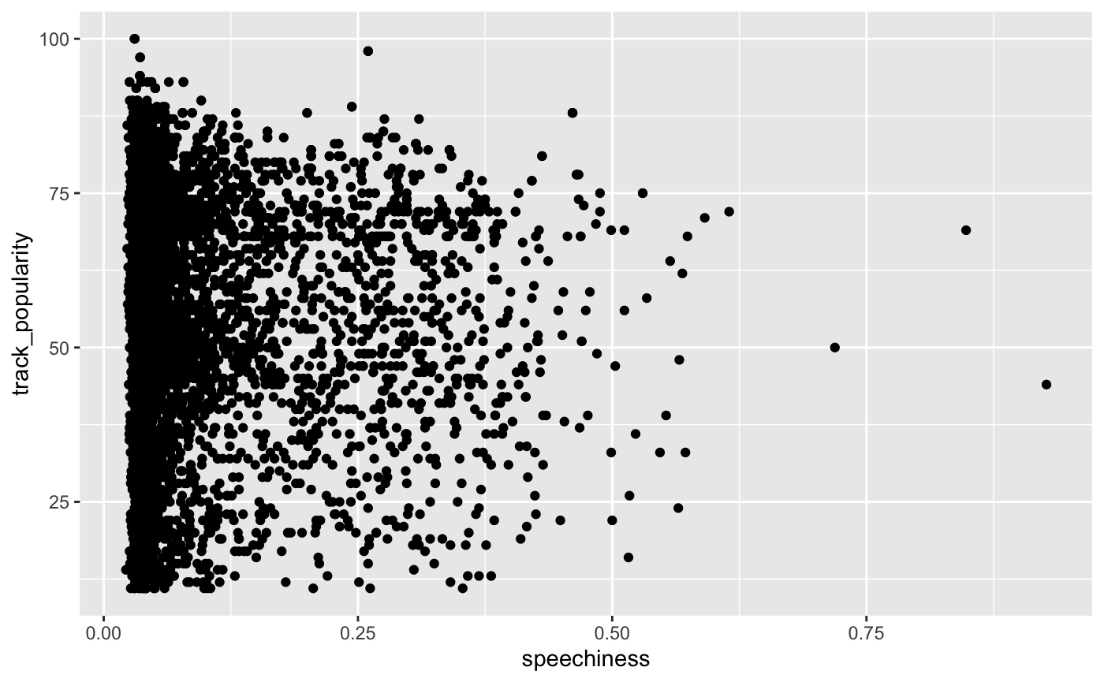
Figure 1. Scatterplot of Speechiness vs Track Popularity

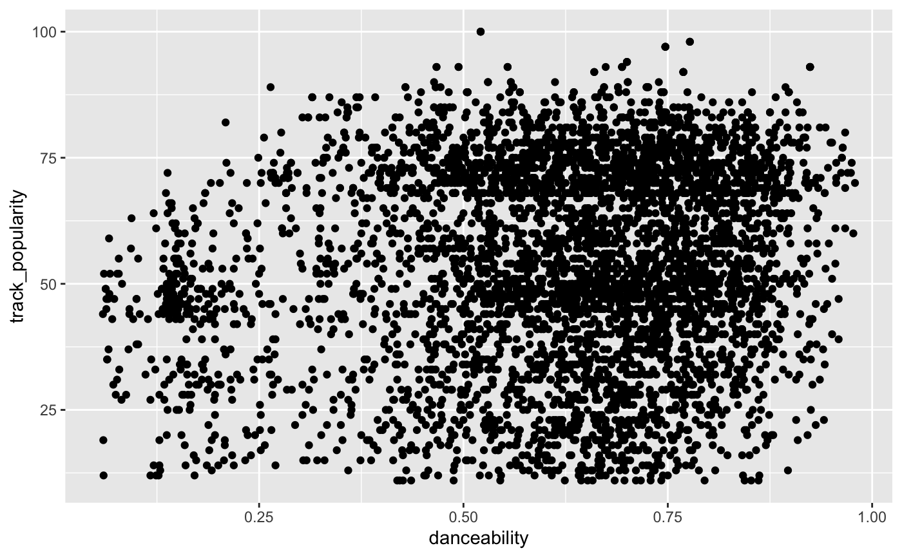
Figure 2. Scatterplot of Danceability vs Track Popularity

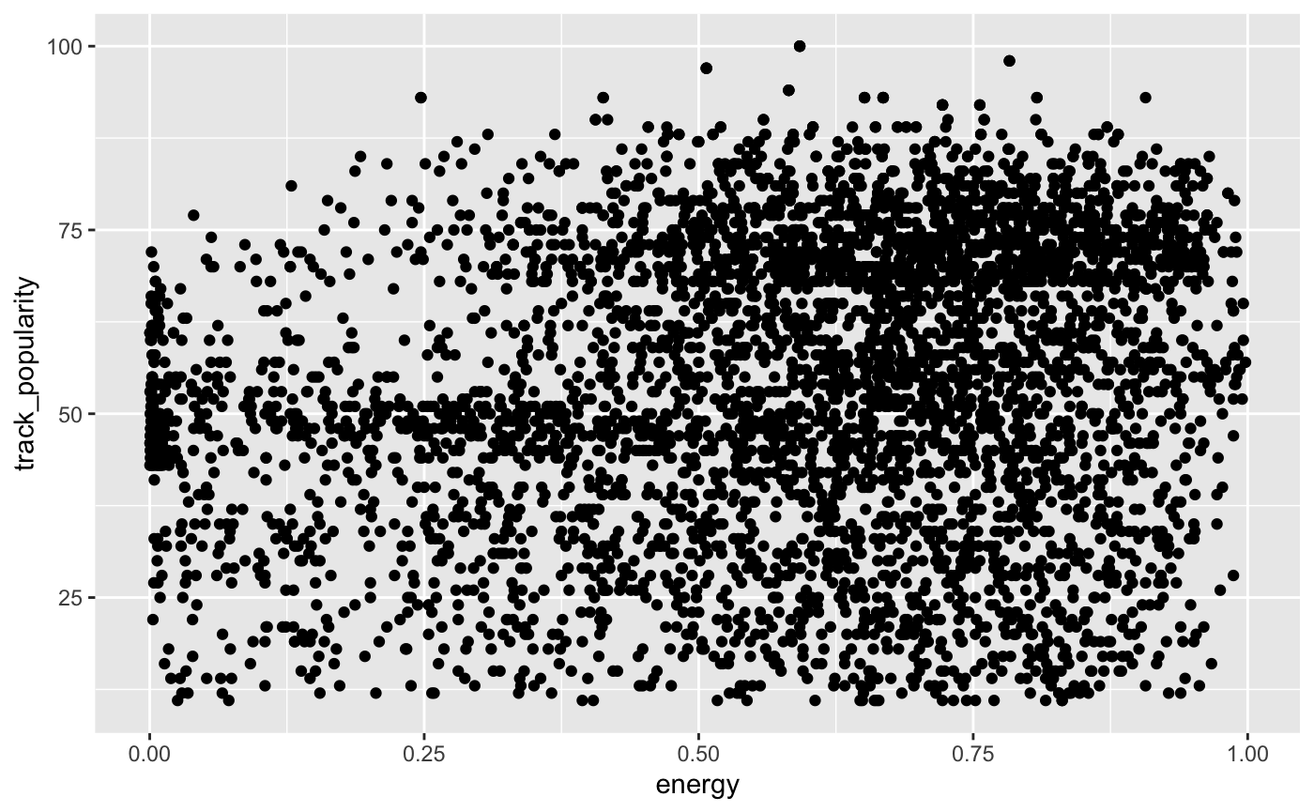
Figure 3. Scatterplot of Energy vs Track Popularity

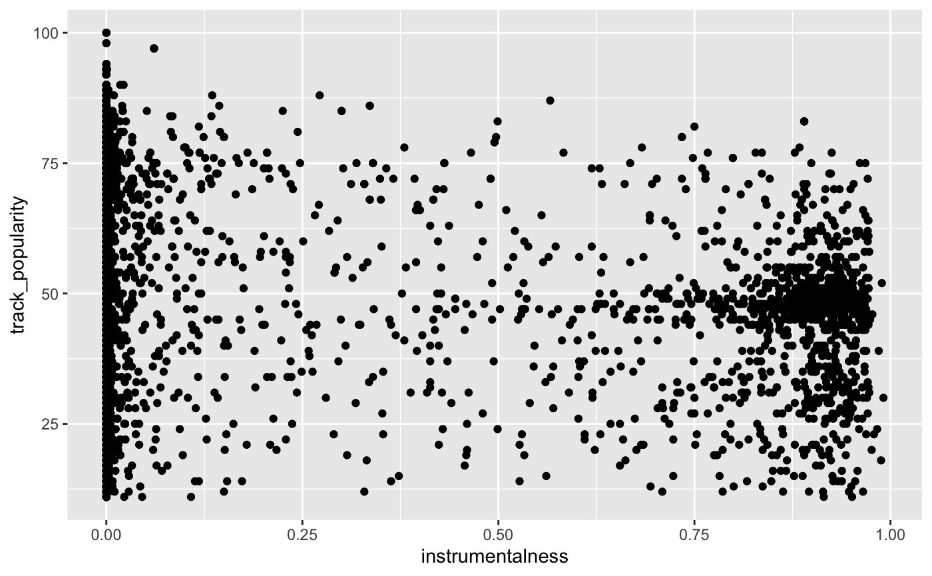
Figure 4. Scatterplot of Instrumentalness vs Track Popularity

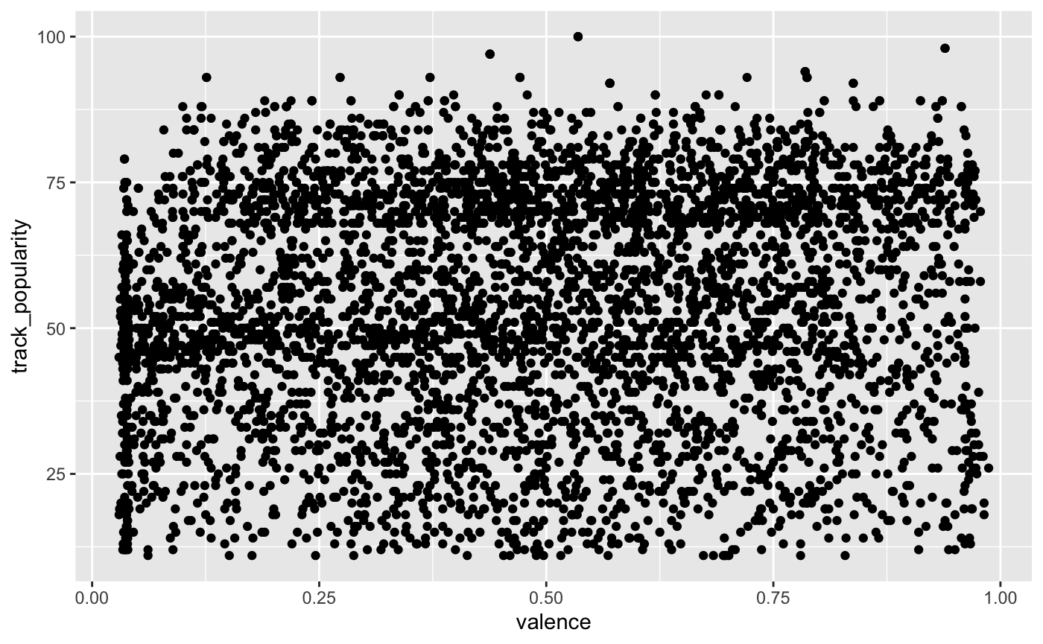
Figure 5. Scatterplot of Valence vs Track Popularity

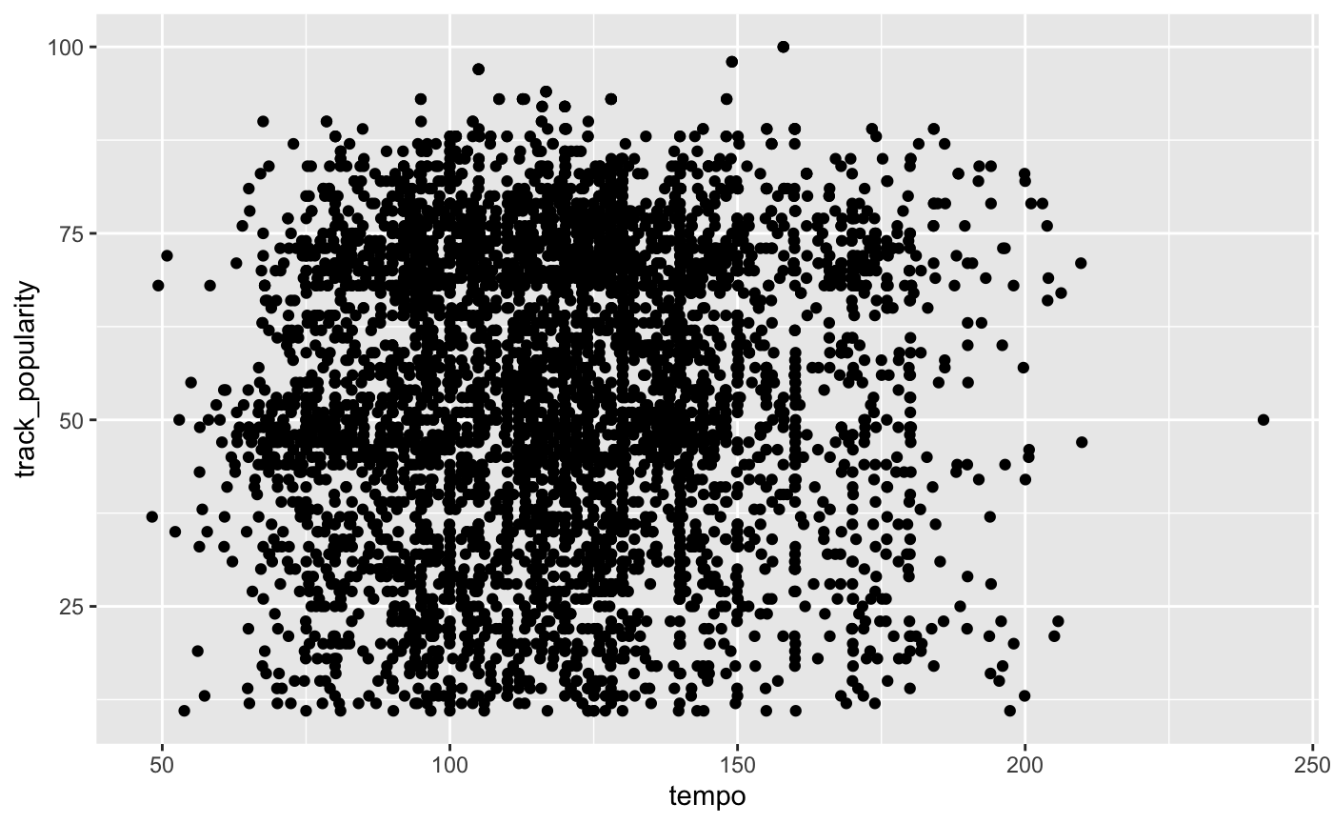
Figure 6. Scatterplot of Tempo vs Track Popularity

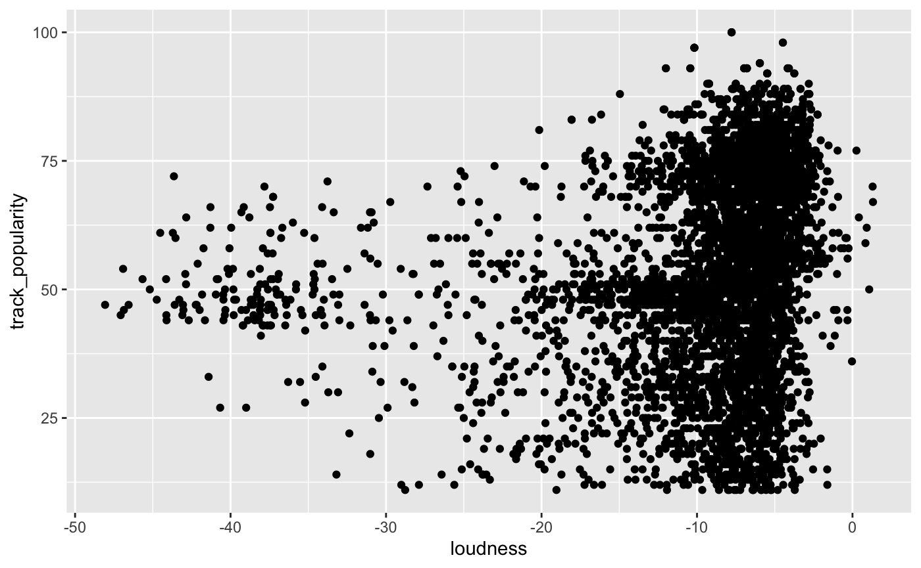
Figure 7. Scatterplot of Loudness vs Track Popularity

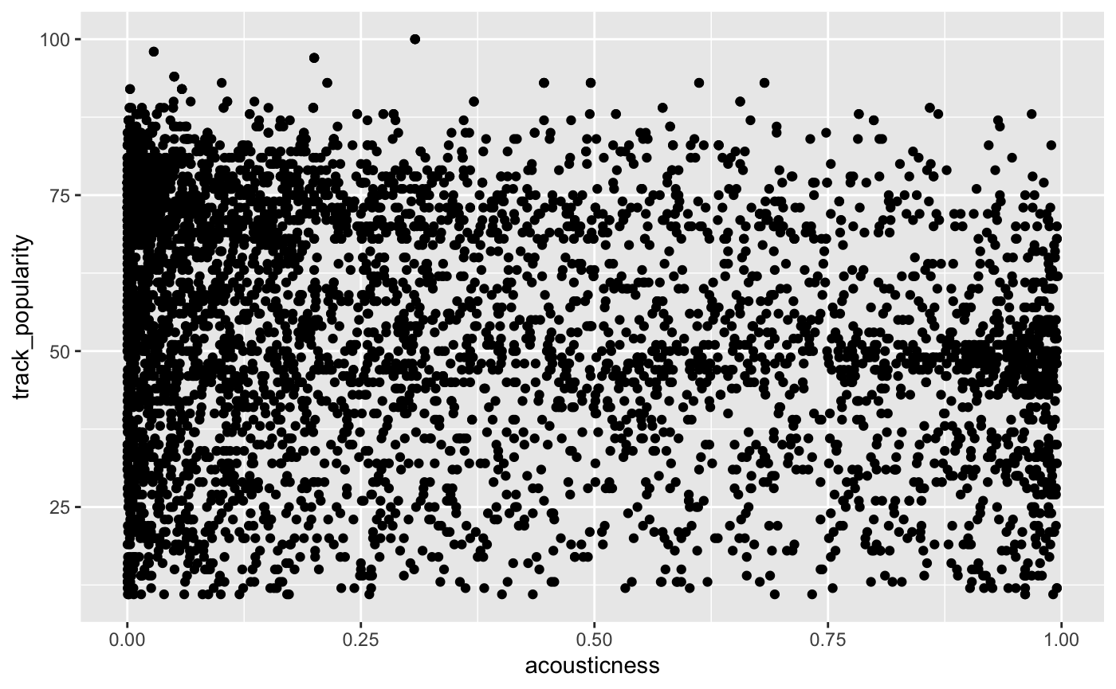
Figure 8. Scatterplot of Acousticness vs Track Popularity

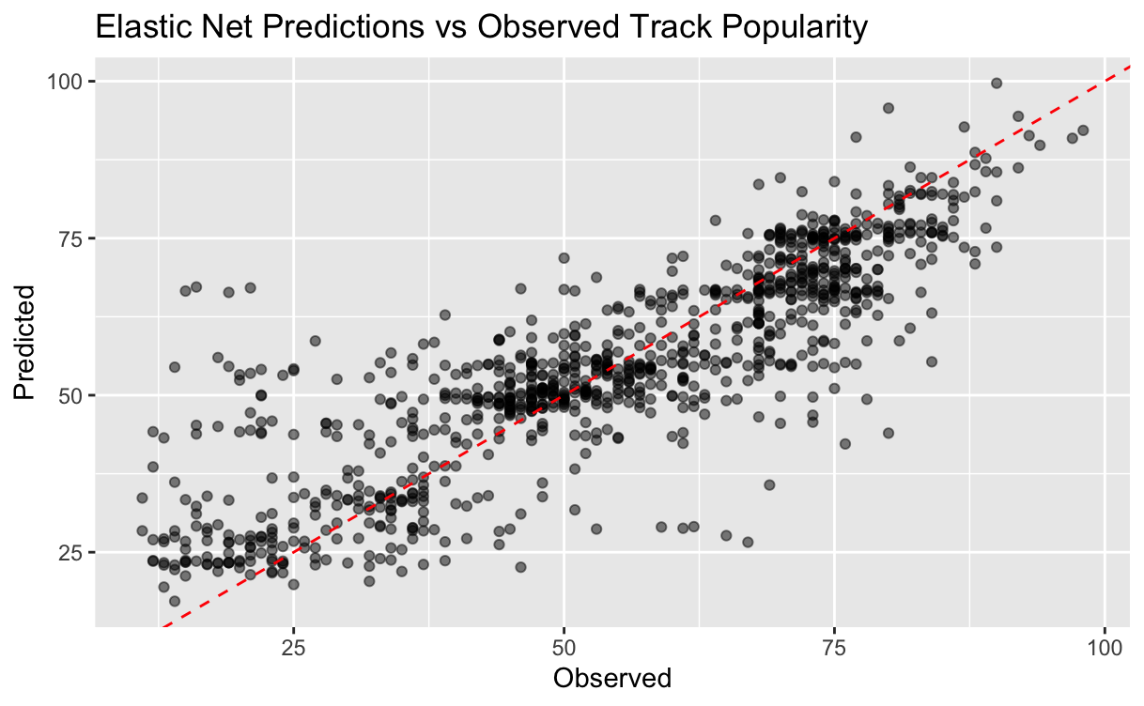
Figure 9. Elastic Net Predictions vs Observed Track Popularity

